**Solar Capstone Project**

From: Raphael Najera, Johnson Liang and Adrian Caprini  
Program: Computer Engineering Technology  
Date: 4/23/2018

# Declaration of Joint Authorship

Adrian Caprini, Raphael Najera and Johnson Liang the group members of the project Solar Capstone, confirm that this report submitted for assessment is the joint work of ourselves, and research which is expressed in our own words. Any uses made within our own works of any other author, in any form (ideas, figures, previous technologies, tables, programs, texts) are properly acknowledged at the point of use. A list of the references used is included. For our group members we have evenly divided the work as follows: Adrian Caprini worked on the Database, Raphael Najera worked on the mobile application, and Johnson Liang worked on the web application.

# Approved Proposal

## Executive Summary

As a student in the Computer Engineering Technology program, we will be integrating the knowledge and skills we have learned from our program into this Internet of Things themed capstone project. This proposal requests the approval to do the software portion that will connect to a database as well as to a mobile device application and web application. The internet connected hardware will include a custom PCB with the following sensors and actuators Solar Panels, PV3. The database will store the data retrieved from the four solar panels PV1, PV2, PV3, and PV4. The mobile device functionality will include information retrieved from the database from the four solar panels. This will give the audience a visual aspect of how much solar energy has been collected and depleted. and will be further detailed in the mobile application proposal. We will be collaborating with the following company/department Kerry Johnston, Humber College Institute of Technology & Advanced Learning North Campus, Prototype Lab, and Humber College Sustainable Energy and Building Technology. In the winter semester we plan to form a group with the following students, who are also building similar hardware this term and working on the mobile application with Raphael, Johnson Liang, and Adrian Caprini. The hardware will be completed in CENG 317 Hardware Production Techniques independently and the application will be completed in CENG 319 Software Project. These will be integrated together in the subsequent term in CENG 355 Computer Systems Project as a member of a 3-student group.

## Background

The problem solved by this project is we can replace a non-renewable energy source with one that is renewable and has less to no impact in our environment. Our project revolves around solar power, which is a clean renewable energy collected from the sun. As a result, by using solar energy it helps reduce greenhouse gas emissions and relying on fossil fuels. Fossil fuels is a heavily relied on source to produce energy however, it will deplete one day. As a result, we need an alternate energy source before all the fossil fuels on Earth has been used. Solar energy is a good alternative and should be invested into because it has an unlimited supply. A bit of background about this topic is the sun produces renewable energy where it is clean and does not generate harmful environmental emissions. If the properties are harnessed then that source of energy can be manipulated to produce electricity, heat, and other valuable energy properties. A solar panel is made of many cells which consist of a positive and negative layer. When the photons collide with the semiconductors on the panel it creates an electric field which are harnessed by the positive and negative layers. The produced energy is multiplied by the number of cells within a panel and the number of panels in a solar array. These panels are then combined together to form a solar panel. (OVO Energy, 2015)

Existing products on the market include [1]. I have searched for prior art via Humber’s IEEE subscription selecting “My Subscribed Content” [4] and have found and read [5] which provides insight into similar efforts.

In the Computer Engineering Technology program, we have learned about the following topics from the respective relevant courses:

• Java Docs from CENG 212 Programming Techniques in Java,

• Construction of circuits from CENG 215 Digital and Interfacing Systems,

• Rapid application development and Gantt charts from CENG 216 Intro to Software Engineering,

• Micro computing from CENG 252 Embedded Systems,

• SQL from CENG 254 Database with Java,

• Web access of databases from CENG 256 Internet Scripting; and,

• Wireless protocols such as 802.11 from TECH152 Telecom Networks.

This knowledge and skill set will enable me to build the subsystems and integrate them together as my capstone project.

## Methodology

This proposal is assigned in the first week of class and is due at the beginning of class in the second week of the fall semester. My coursework will focus on the first two of the 3 phases of this project:

Phase 1 Hardware build.

Phase 2 System integration.

Phase 3 Demonstration to future employers.

*Phase 1 Hardware build*

The hardware build will be completed in the fall term. It will fit within the CENG Project maximum dimensions of 12 13/16" x 6" x 2 7/8" (32.5cm x 15.25cm x 7.25cm) which represents the space below the tray in the parts kit. The highest AC voltage that will be used is 16Vrms from a wall adaptor from which +/- 15V or as high as 45 VDC can be obtained. Maximum power consumption will be 20 Watts.

*Phase 2 System integration*

The system integration will be completed in the fall term.

*Phase 3 Demonstration to future employers*

This project will showcase the knowledge and skills that I have learned to potential employers.

The brief description below provides rough effort and non-labour estimates respectively for each phase. A Gantt chart will be added by week 3 to provide more project schedule details and a more complete budget will be added by week 4. It is important to start tasks as soon as possible to be able to meet deadlines.

No other purchases are required for this project as we will be using solar panels located on the roof on the L-wing.

Raspberry Pi 3: used to run the python code to retrieve the data from the website that contains the data of the solar panel and then save the data to the firebase

## Concluding remarks

This proposal presents a plan for providing an IoT solution for this concept that could be used for homes and businesses that have installed solar panels on their roofs. This would show the data from the solar panels from the sunlight when they are running. With the information that is retrieved, the data will be stored in the database. The user will be able to retrieve the information by using the app on their smart phone. As a result, users will be able to keep track the amount of energy the solar panels have collected, CO2 avoided, and energy depleted. This is an opportunity to integrate the knowledge and skills developed in our program to create a collaborative IoT capstone project demonstrating my ability to learn how to support projects such as the initiative described by [5]. I request approval of this project.

# Abstract

Solar power is clean renewable energy collected from the sun. If this energy is harnessed properly it can be transformed and utilized for different properties. This system can be used to convert light energy into electricity or other elemental properties. Most importantly, by using solar energy it will help reduce greenhouse gas emissions and relying on fossil fuels. There are four solar panels located on the roof of the L building at Humber College North Campus and these four panels are consistently collecting energy from the sun. At the start of this project, we visited room L240 to inspect how the solar panels were communicating and connected. Through our investigation we found all the IP addresses each solar panel was reserved and communicating on Humber's network. PV1 is communicating using the IP address 10.116.25.7, PV2 is 10.116.25.5, PV3:10.116.25.8, and PV4: 10.116.25.6. With our observation there were significant fields we wanted to retrieve and this consisted of power, daily and total yield energy. PV3 was slightly different from the other PVs as we retrieved battery voltage, AC input and output, and power. However, PV3 was divided into two sub categories which were called inverter and charge controller.

Our task is to implement a system that will monitor how much solar energy is collected and the total amount of energy collected every 30 minutes. This data gathered from the four solar panels will then be stored in a database. The data will be available for users to access through our mobile and PC application. The mobile application will retrieve the data from the solar panel PVs and display the information. The web application will also display the data retrieved from the solar panel in the form of a PC GUI. The users can then access this data globally from our web or mobile application. Provided that a user has connection to internet this data can be accessed universally. The website will be hosted on GitHub and locally on Humber's network, this way it gives an alternate way to be viewed anywhere in the world. This system can be used to help educate the community about the significance of using renewable energy rather than fossil fuels. For example, the purpose of using clean renewable energy and the importance of avoiding greenhouse gas emissions and the purpose for using clean renewable energy. This project we collaborated with Kerry Johnston whose part of Humber's Sustainable Energy and Building Technology. As students from the Computer Engineering Technology program at Humber College, we have decided to participate in helping create a platform to observe these energy readings. Our platform will be advertised in the lobby of the LRC or the L building for the Humber community. This platform will also be available exclusively to Android OS and can be viewed on one's phone.

Table of Contents

Declaration of Joint Authorship 2

Approved Proposal 3

Executive Summary 3

Background 4

Methodology 5

Concluding remarks 7

Abstract 8

Illustration Lists 12

1. Introduction 13

2. Project Description 14

2.1 Problem 14

2.2 Rationale Behind Project 15

2.3 Project Scope 15

2.4 Software Requirement Specifications 16

2.5 Build Instructions 19

2.5.1 Introduction 19

2.5.2 System Diagram 19

2.5.3 Bill of Materials/Budget 20

2.5.4 Time Commitment 21

2.5.5 Power up 21

2.5.6 Software Assembly 21

2.5.7 Database 24

2.5.8 Mobile Application 27

2.5.9 Web Application 34

2.5.10 Unit Testing 36

2.5.11 Production Testing 38

2.6 Problems Encountered 39

2.6.1 Solar Panel PV website 39

2.6.2 Solar Panel PV3 39

2.6.3 Access to the solar panel website 40

2.6.4 Limited space of Firebase 40

2.6.5 If Solar Panel website was down 40

2.7 Approaches 41

2.7.1 Solar Panel PV website 41

2.7.2 Solar Panel PV3 41

2.7.3 Access to the solar panel website 41

2.7.4 Limited space of Firebase 42

2.7.5 If Solar Panel website was down 42

2.8 Walkthrough of System 42

2.8.1 Solar Panels PVs 42

2.8.2 Raspberry Pi 42

2.8.3 Firebase 43

2.8.4 Mobile Application 43

2.8.5 Website Application 43

3. Progress Reports 44

3.1 Status Report A 44

3.2 Status Report B 46

3.3 Status Report C 48

4. Conclusions 51

5. Recommendations 52

6. Technical References 53

7. Appendices 54

# Illustration Lists

2.5.2a: Solar Capstone Project System Diagram p.21

2.5.7a: Screenshot of PV1 table p.26

2.5.7b: Screenshot of PV2 table p.27

2.5.7c: Screenshot of PV3a table p.27

2.5.7d: Screenshot of PV3b table p.27

2.5.7e: Screenshot of PV4 table p.28

2.5.8a: Screenshot of home screen on Solar Light app p.29

2.5.8b: Screenshot of PV1 on Solar Light app p.30

2.5.8c: Screenshot of PV2 on Solar Light app p.31

2.5.8d: Screenshot of PV3 on Solar Light app p.32

2.5.8e: Screenshot of PV3 History log on Solar Light app p.33

2.5.8f: Screenshot of PV4 on Solar Light app p.34

2.5.8g: Screenshot of about screen on Solar Light app p.35

2.5.9a: Screenshot of the Web application p.37

2.5.10a: Testing data on the firebase p.38

2.5.11a: Screenshot of the solar capstone code running p.39

2.5.11b: Screenshot of the output when the Solar Panel PVs are offline p.40

# 1. Introduction

Fossil fuel has been the Earth's main source of energy for many centuries, but this source will one day be depleted and extinct. Instead, we have to educate and make ourselves aware of an alternate energy source such as solar energy. Unlike fossil fuels, solar energy is renewable and clean from the sun, and with the current advancements it can help reduce greenhouse gas emission and the cost of money. We will integrate a solution which will help the community be aware of the significance revolving around clean energy.

This project revolves around solar panels and the Sunny Boy sensor box to gather data on how much solar energy is collected from each solar panel and the total amount of energy collected every month and year. The information stored on the database will be retrieved so that it can be read and display on our mobile and web application, so that users can access this information from their cell phones, website or publicly at Humber College. It is possible to monitor all four solar panels within the application and displaying the information of each one by clicking the different tabs in our mobile application.

The idea of the solar panels is for Humber to use renewable energy, eliminate fossil fuel usage, to show the Humber community how solar energy works and how much solar energy the solar panels produce. Also, the Humber community would be able to see how much solar energy the Humber retrieved each day. By having access to this data, individuals interested in this data will have live up-to-date records and observe how much solar energy Humber uses on a daily or monthly basis.

# 2. Project Description

## 2.1 Problem

There were a couple problems with the current status of this project before we started working on it. The first major problem was no communication between the solar panels and its corresponding IP addresses. As a result, we could not access any of the HTML files in order to read its data. The second problem was the IP for PV3 was not working properly and could not access the website for PV3. Therefore, no data could be retrieved from it. PV3 retrieved data differently from the other PVs, it was not straight-forward and had two different sub categories. The third problem we had was that the current system does not display any information on the screen that is in the L building first floor of the Humber College North Campus. Our goal was to display information on the screen by creating a web application to display in the L building first floor. Finally, we had to understand how the whole system was set up so that we can understand how the system functions. This was needed to determine the first step of what we needed to do in order to make this project successful.

## 2.2 Rationale Behind Project

We decided to partake in this project because it gives us an opportunity to work on an industrial level project and collaborate with professionals. Additionally, to show the Humber community the skills we have learnt in past three years in our program. This project also gives us an opportunity to work in teams and understand the importance of teamwork and work habits. Through this experience we had the opportunity to observe our own and team members' strengths and weaknesses. This allowed us to further assess our own capabilities and improve our skills. With that being said, we can improve as an individual and understand our work habit through this course. Also, we wanted to help the college by trying to get this entire project to work properly and produce the desired end result, which is to be able to display the data of each solar panel PV's on the mobile and web application, and on the computer screen that is located in the first floor of the L building of Humber College North Campus. By doing so we can advertise the different knowledge we have obtained in the past three years of our study. This can allow future students to be more aware of the type of skills they will be achieving.

## 2.3 Project Scope

The scope of this project is creating a database, mobile application and web application to get and retrieve the data from each of the solar panels PV to display it on a mobile application, web application and on a monitor screen in the first floor of the L building of Humber College North Campus. The database will have five tables, one for solar panel PVs 1, 2 and 4 and two tables for PV3. The mobile application will have a main screen, splash screen, about page and a navigation drawer that has a log and history on the tab layout for each of the solar panel PV's. Also, it will have four separate screens one for each of the solar panel PVs and a history log for each of the solar panel PVs. The app will also include an action bar which link to the Humber website and to our solar panel web application. The web application will be one page, split in four, one for each of the solar panel PVs. Also, it will show a history log for each of the solar panel PVs and readings that it is getting from the database.

## 2.4 Software Requirement Specifications

2.4.1 Database

The project will include five databases, each database contains data from each of the four solar panels. Our database allows for up to one free GB and beyond that you will have to pay to store more entries. The databases will be created using Firebase by creating a google account to be able to log into Firebase. There will be five tables, one for solar panel PV's 1, 2 and 4 and two for PV3. The databases will be used to store the information from the PV's of the four solar panels. The information stored on the databases will be retrieved so that it can be read on our mobile and web application, so that users can access this information from their cell phones or publicly at Humber College. The data being stored in each database will include how much solar energy is collected from each solar panel, the time of each update, the total amount of energy collected every month and year and the epoch time to help us to know when it has been 30 days so that the data can then be deleted. We will write a python code to get and retrieve the data from the solar panel PV's. Also, we will write a python code that deletes old entries up to 30 days from each solar panel PV every 30 days.

2.4.2 Mobile Application

This project will include a mobile application which is currently available for Android platforms. The mobile application will be called Solar Light. This app will take the data from the solar panel PVs, which is stored on the firebase and display them on the app. The user will be able to see how much solar energy has been collected from each of the solar panel PVs each day. In each of the PV's screen will display data and history log in the tab layout. In the data section it will contains which PV you are looking at, the current time, the last updated data it retrieved from the firebase which will include the date and time, power, daily yield, and total yield. In the log section it will contains log of the previous data that it retrieved from the firebase up to 12 entries. The log is display in a Listview. The app will include a main screen which will display more information about the solar panels, importance of using solar energy and the manufacture of the four solar panels. Before the app opens, it will display a splash screen of the app logo. On the action bar, it will display link to the Humber website, Solar Capstone Web application and about information. (Developed by Raphael Najera)

2.4.3 Web Application

The web application will function similarly to the mobile application where both will display data retrieved from the solar panel stored in the database. The difference between the two is one will be accessed from the phone while the other is globally advertised. The website will also be available to be accessed using GitHub and can track across the world. The web application will be displayed on a monitor in the L building, where the Humber community can observe the school's solar resources. As a result, the community will be able to observe the amount of solar energy collected from the sun daily and total. The design of the web application is the HTML is split into four frames and displays the corresponding information. The community will also be able to observe the status of each solar panel whether its active or inactive. The status of a solar panel is active when the power greater than 0 watts and is inactive if its less than 0 watts. Essentially if it's daytime its active and inactive during the night. The purpose of this is for debugging purposes like knowing if the solar panel is still collecting data or not. As a result, the moderator can reset and easily identify the problem if the system is not functioning as is. In the fourth frame it also displays the weather status in Toronto. This is an additional feature for aesthetic purposes and to make the overall look application more appealing. This graphical user interface is intended to be built using Notepad++. (Developed by Johnson Liang)

## 2.5 Build Instructions

### 2.5.1 Introduction

The software system project we decided to work on this semester involves four solar panels located on top of the L building of Humber College North Campus. The purpose of this project was to interact and store the gathered data from all four solar panels into a database. Then, with the retrieved information we intend to display it on our mobile and web application. The data we will be retrieving from the solar panels consist of the power, daily and total yield energies. These four solar panels are manufactured from three different companies. For example, the PV1 and PV4 hardware was manufactured by Sunny Webbox, PV2 was manufactured by Envoy Communications Gateway and PV3 manufactured by Outback. The hardware for our project was already provided and installed for us so our main focus was to create the software aspect. At the end of this project we want to be able to retrieve the pushed data on our firebase. This data will be displayed onto our mobile and web applications for the Humber community and users to observe how solar panels work, and how much solar energy has been collected and expended.

### 2.5.2 System Diagram

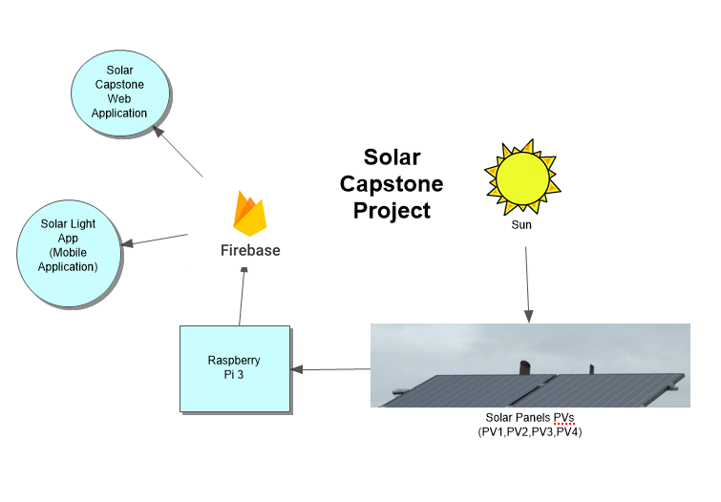

Image 2.5.2a: Solar Capstone Project System Diagram

### 2.5.3 Bill of Materials/Budget

The materials needed to replicate the Solar Capstone Project are solar panels and a Raspberry Pi. The solar panels were provided by the school and we bought the Raspberry Pi from Amazon. The solar panels were manufactured by the companies Envoy Communications Gateway, Sunny Webbox and Outback Power.

1. Raspberry Pi 3 (CanaKit Starter Kit): CAD $99.99

Link: https://www.amazon.ca/CanaKit-Raspberry-Complete-Starter-Kit/dp/B01CCF6V3A/

1. Solar Panel PVs (Provided by Humber College):

PV1 and PV4: Sunny Webbox

PV2: Envoy Communications Gateway

PV3: Outback Power

### 2.5.4 Time Commitment

This project can be completed with a group of three people or individually. However, if completed in a group the tasks can be divided and completed quickly compared too individually. This project can be completed in the span of 13 weeks where each task is divided weekly. For example, one week we will write python code to retrieve specific data and another week we can write code to push the retrieved data into a database. At the end of the project we will present our completed application which will be able to successfully retrieve pushed data from the firebase. In this case, we had specific individuals focus on the database, mobile application, and web application. Since we were relatively new to python scripting we shared the task together. As a result, we all had the opportunity to learn a new programming language.

### 2.5.5 Power up

If you are booting up the Raspberry Pi for the first time, insert the micro SD card to the SD card reader from the Raspberry Pi package and make sure that the correct operating system is pre-installed. If it is not, the OS can be downloaded from this link: https://www.raspberrypi.org/downloads/noobs/. Once the OS has been installed on the Raspberry Pi, insert the micro SD card into the Raspberry Pi and power it. After doing this, the Raspberry Pi should then boot up. Before going further, users will be required to set up the operating system and configure their Raspberry Pi settings and Wi-Fi.

### 2.5.6 Software Assembly

The data came from four different sources and so, we needed to pick a database which would store the data under one platform. As a result, we decided to use Firebase as it's free to use and can be easily accessed. Additionally, we have experience with using Firebase from CENG319: Software Projects. We also had to decide the platform we wanted to use to create the mobile and web application. We choose Android Studio to create our mobile application and Notepad++ to create the web application. The web application is created using HTML and JavaScript which will be locally hosted on the PC and hosted on GitHub.

Furthermore, a Python script is required to retrieve and push data into our Firebase.

The python code we created will retrieve the solar panel data from the solar panel websites hosted on Humber's network and store the data on Firebase. The python code will also pull data from the firebase to delete old entries up to 30 days by using the epoch time of each entries and comparing the current epoch time of the last 30 days. Entries in the range from 1 to the last 30 days will delete the old entries which will create more space to store the new entries because our firebase can only hold 1GB of data. User can see the code we made which can be downloaded here: https://minhaskamal.github.io/DownGit/#/home?url=https:%2F%2Fgithub.com%2FRaphaelNajera%2FSunlight_Sensor%2Ftree%2Fmaster%2Fdocumentation%2FCENG355%20Solar%20Capstone%2Ffirmware

The steps to run the Solar Capstone python code on the raspberry pi:

1. Power up the raspberry pi and set up VNC server on the raspberry pi
2. On the PC, download and run VNC viewer. With VNC viewer you can remotely connect to the raspberry pi
3. On the raspberry pi before running the code, you have to set the default python to python 3 and install the following modules which is required to run the code.

On the terminal type the following code to set the default python version to python 3.5.3.

nano ~/.bashrc

When you open ~/.bashrc, add new alias to change the default python executable.

alias python='/usr/bin/python3'

After you added the new alias, save the file, and enter this command.

. ~/.bashrc

Next enter the following command to install the python librarys.

pip install --upgrade setuptools

sudo apt-get install libxml2-dev libxslt-dev python-dev

sudo apt-get install python3-lxml python-lxml

pip install beautifulsoup4

pip install pyrebase

pip install apscheduler or pip3 install apscheduler

The following python librarys are required because with beaultifulsoup 4, it has the function to allow the code to read the solar panels html that is hosted on the Humber network and retrieve the data from the PV’s website.The pyrebase allow us to push the data that the code retrieved from the website to the firebase and allow us to pull the data from the firebase which we can use to delete old entries. The apscheduler allow us to schedule the functions we create on the python script which will allow the functions to run a certain amount of time. For example, we have a function that reterived the data from the solar panels website and then push the data to our firebase. This function is schedule to run every 30 minutes. The second function is it pull the data from the firebase to compare with epoch time to delete old entries up to 30 days. This function is schedule to run every 30 days.

1. Once you got the module installed, you can now run the code. The code will loop every 30 minutes to push the data to the firebase and every 30 days it will delete old entries from the firebase up to 30 days.

python Solar_Capstone_PV_v8.py

### 2.5.7 Database

To create a Firebase account by using Google Mail to access exclusively to your database. To access it you need to log into your created Firebase account using Google Mail and then click on the data tab to see the tables for each of the solar panel PVs. Then to see the data for each of the solar panel PVs, click on the + icon beside the table title to expand each table to see each data that was retrieved and then click the + again on that data in the table to see the data stored. Then we had to create the tables for each solar panel PV and then test the code we wrote with placeholder values. We decided to split PV3 into two tables because the website for PV3 where we were trying to retrieve the data from had two different tables with different data so we decided to split it into two tables instead of trying to retrieve that data and store it all in to one table. Next, we wrote the python code that is going to be used to get and retrieve the data from firebase. This python code will execute every 30 minutes to fetch the latest results and push it into firebase. Also, there will be a python code that will be written in order to delete all the old entries from the database after 30 days so that we don't run out of storage. The firebase is limited to hold data up to 1gb. To do this, we will need to retrieve the epoch time to be able to delete all the old data after 30 days. Since we have a limited amount of storage, this is the current solution that we have come up with. However, the epoch time will not be displayed to the user as it is for the programmer’s use instead the user will see the time and data that the entire was retrieved.

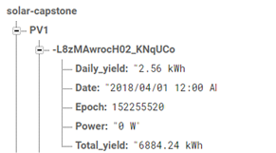

Image 2.5.7a: Screenshot of PV1 table

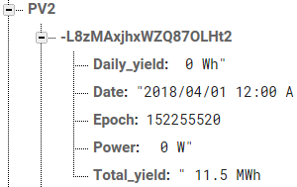

Image 2.5.7b: Screenshot of PV2 table

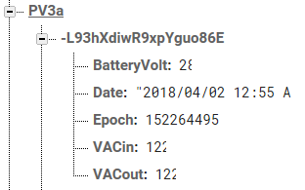

Image 2.5.7c: Screenshot of PV3a table

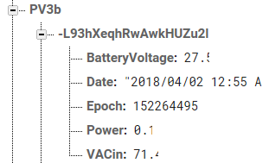

Image 2.5.7d: Screenshot of PV3b table

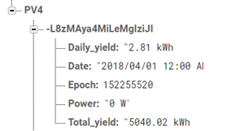

Image 2.5.7e: Screenshot of PV4 table

### 2.5.8 Mobile Application

Android Studio was the software we decided to use to make the counterpart of the mobile application. Our app connects to Google’s Firebase where it will retrieve existing live data ran 24/7 on an external device running a python script. Our application is called “Solar Light” because it our project revolves around collecting solar energy produced from the sun. Once the app is created we then setup the app to connect our firebase by clicking Tools tab located on the menu bar, and then Firebase. On the firebase assistant we clicked on analytics and then log an analytics event. We followed the steps such as login to the firebase, so the app can connect to the firebase and then adding the code to read from the firebase. Then we create four different screens for each of the four PV's by creating a navigation drawer for the solar PV's. Each of the PV's will display which PV you are looking at, the current time. The data it retrieves from the firebase which contains the last updated data and time, power, daily yield, and total yield. It will also show a log of the pervious data that it retrieved from the firebase up to 24 entries. To access them is we use TabLayout which you swipe from side to side to access the data and log or by clicking on the data tab or log tab. The app will include a splash screen containing the app icon and main screen which will display more information about the solar panels, the importance of using solar energy and the solar panels manufacture. On the action bar, it will display link to the Humber website, solar capstone web application and about information which contain the app about, who made the app and the version number.

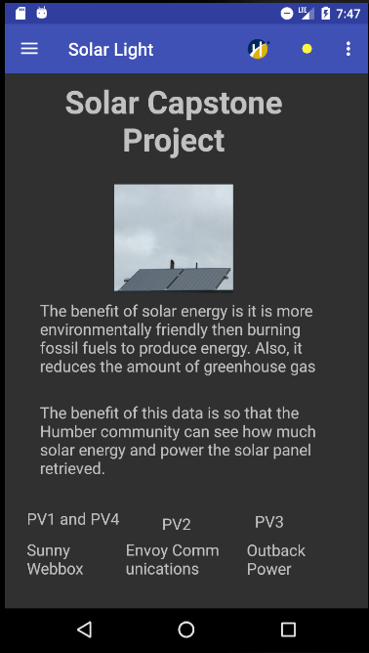

Image 2.5.8a: Screenshot of home screen on Solar Light app

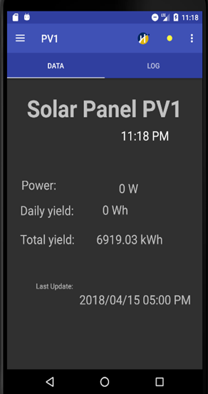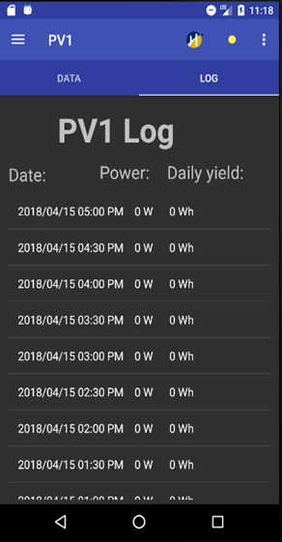

Image 2.5.8b: Screenshot of PV1 on Solar Light app

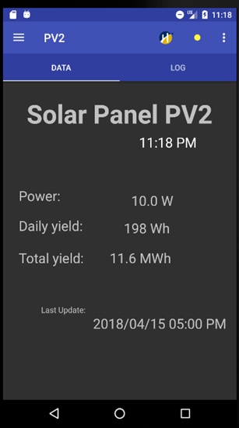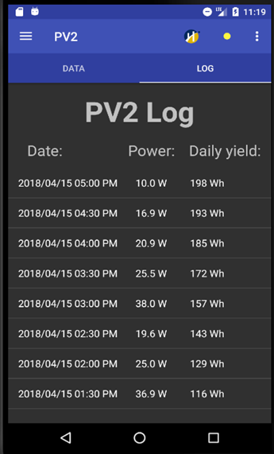

Image 2.5.8c: Screenshot of PV2 on Solar Light app

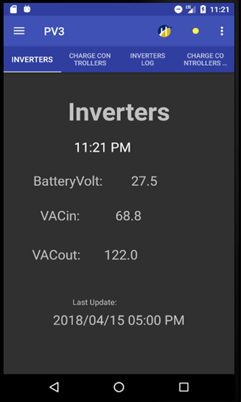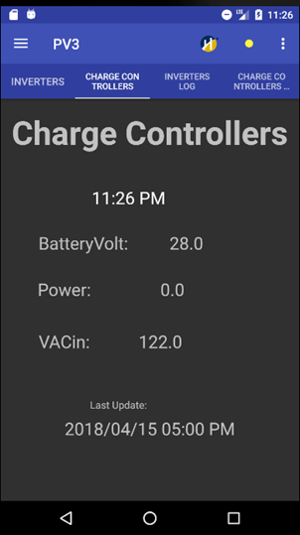

Image 2.5.8d: Screenshot of PV3 on Solar Light app

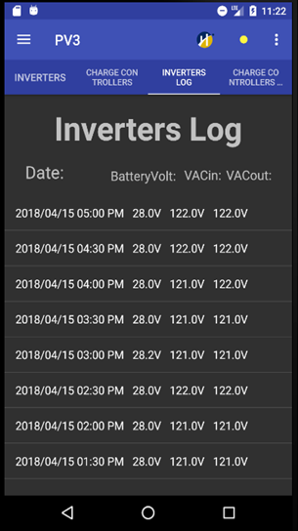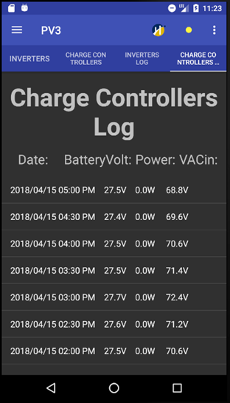

Image 2.5.8e: Screenshot of PV3 History log on Solar Light app

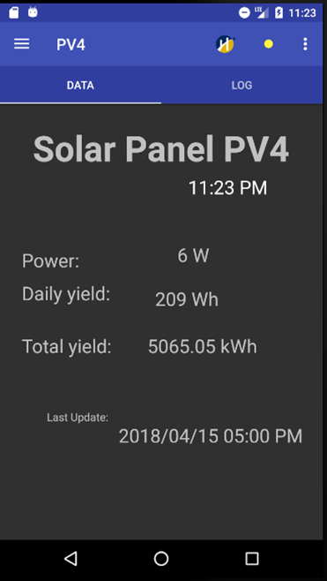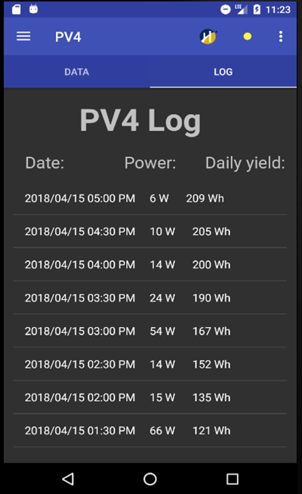

Image 2.5.8f: Screenshot of PV4 on Solar Light app

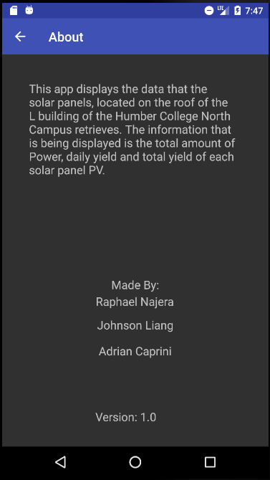

Image 2.5.8g: Screenshot of about screen on Solar Light app

Link to the GitHub Solar Light application:

https://github.com/RaphaelNajera/Solar-Capstone-App

### 2.5.9 Web Application

The web interface was simply created using Notepad++ where one HTML document linked to four separate HTML forms. The HTML linked to four different frames and consisted of different panes that displayed four different sections. It is chronologically ordered so that users have a good idea of which solar panel is which. In each of these frames it will display the current PV panel and latest data retrieved from the last query of the database. The last query will display the last entry of the power, daily and total yield energy in watts. Overwriting the element to display the latest query is accomplished using getElementById and data field length - 1. It is subtracted by length –1 because the length determines how long the array list is. Since this is a recursive script there is no cap on how much the database can hold, -1 will retrieve the last entry. In our application, based on the power it will also display the status of each solar panel. If the power is greater than 0 watts the solar panel will be active and inactive below 0 watts. We later added another status where if the webpage was down then the status would display offline. The method each HTML file is retrieving data is based on JavaScript. With that being said, the application uses a for loop to retrieve the last couple of entries from the database and place it under the <table> tag using the createElement method. Additionally, it will retrieve an array of data which is simply the history of all the fields. As such this allows the user to observe how much data has been collected every 30 minutes to previous hours. This HTML can be hosted locally or through a domain service such as GitHub and will be able to be open on any browsing platform.

Link to the GitHub Solar Capstone Web application:

https://github.com/j-liang/solarcapstone_web

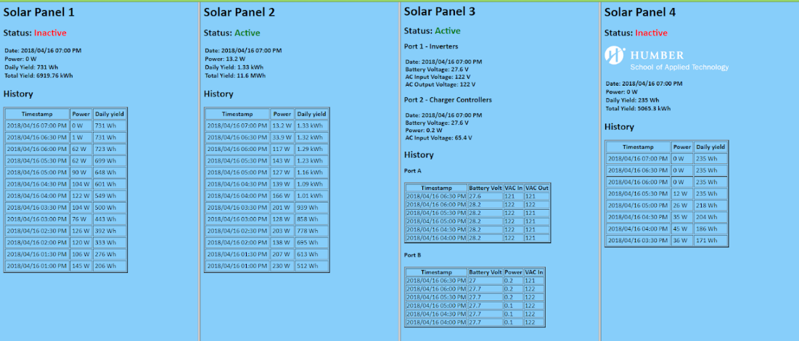

Image 2.5.9a: Screenshot of the Web application

### 2.5.10 Unit Testing

We did a lot of debugging and testing in order to check if specific tags were found with certain data. We also test to see that the old entries are being deleted by comparing the epoch time to the current epoch time minus 30 days. In order to achieve this, we wrote a python script to complete this task then we defined functions to push data into a pre-made firebase and also pull data from the firebase. However, prior to running the script we have to ensure that the raspberry pi is set up with installed python libraries in the terminal which is explained under software assembly. Once the data has been stored it can be retrieved and be listed into our mobile and web applications. The mobile app can run on android devices and it will retrieve the required information. The web application can be run on any Internet browser and it will retrieve the required information.





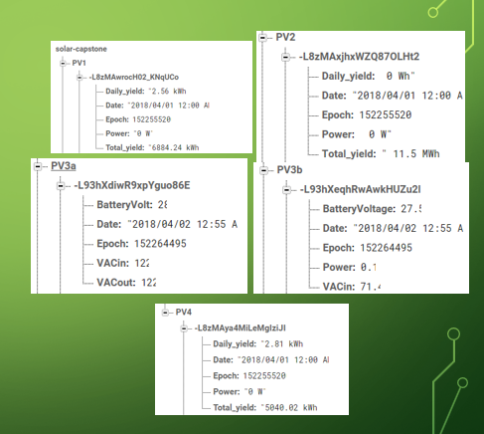



Image 2.5.10a: Testing data on the firebase

### 2.5.11 Production Testing

Once we successfully ran the python code on the raspberry pi, it will display the name of the solar panel PV's, epoch time, date, power, daily yield and total yield information from each of the solar panel. If the solar panel PV's website is down it will display that solar panel is offline message. For example, if the website for solar panel PV1 is down it will display "Solar Panel PV1 is offline". Our python code will be running 24/7 which the code will keep looping so that as it progresses the status will change. This will allow our mobile application and web application to display date, power, daily yield, and total yield from each of the solar panel with the current and updated status.

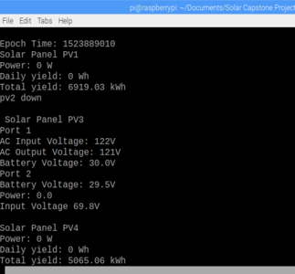

Image 2.5.11a: Screenshot of the solar capstone code running

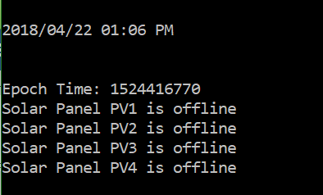

Image 2.5.11b: Screenshot of the output when the Solar Panel PVs are offline

## 2.6 Problems Encountered

### 2.6.1 Solar Panel PV website

At the beginning of the project we were unable to access the website to the solar panel PV's to retrieve the data from the solar panel because the IP address for the solar panel PV1, PV2, PV3 and PV4 was changed and not setup for access.

### 2.6.2 Solar Panel PV3

For solar panel PV3, the problem we encountered was what data we had to display for PV3 since the data was different from the other solar panel PV's. The data was retrieved into two tables, Port 1 as Inverters and Port 2 as Charge Controllers. The inverters contain AC Current to Loads, AC Charge Current for Batteries, Buy Current for Load and Batteries, AC Input Voltage, AC Output Voltage, Sell Current and Battery Voltage. The Charge Controllers contain Charger kWh, Charger Amps DC, PV Amps DC, Daily Ah, PV Voltage, Battery Voltage.

### 2.6.3 Access to the solar panel website

To access the solar panels website, we had to be on campus in order to test if the python code we were using was working properly. The hardware for the solar panels website was configured to be hosted locally on Humber's network which you can only access the website if the computer is connected to the Humber network. Our laptop connected to WIFI or connected outside Humber's network was unable to access the Solar Panels websites due to the hardware configuration of the solar Panels. If we tried to test the code at home it would give us an error that said the website is down or timed out.

### 2.6.4 Limited space of Firebase

The firebase we used has a limited amount of space for storing the data. The firebase can store up to 1 GB of data. Right now, our python code pushes new entries every 30 minutes to our firebase which will result in filling our firebase with lots of entries. Once the firebase is filled with lots of entries we will not be able to store new entries and this will cause delays on loading the entries due to the number of entries.

### 2.6.5 If Solar Panel website was down

In our python code if the website of the solar panel PVs were offline this would give us an error in the output which would stop the python code from running. As a result, we would have to restart the code to run it again.

## 2.7 Approaches

### 2.7.1 Solar Panel PV website

The solutions to this problem was us waiting for the IT department who configured the solar Panel PV's originally to set up the IP addresses to the solar panel PVs which would allow us to access the solar panel website. PV1 is communicating using the IP address 10.116.25.7, PV2 is 10.116.25.5, PV3 is 10.116.25.8, and PV4 is 10.116.25.6.

### 2.7.2 Solar Panel PV3

To solve this problem for Solar Panel PV3 on what data to save to the firebase and display to our mobile and web app we decide to retrieve some of the data to be pushed to the firebase. For Port 1, Inverters we decide to retrieve BatteryVolt, VACin and VACout. For Port 2, Charge Controllers we decide to retrieve BatteryVolt, Power, VACin. For both ports we also pushed the date, time, and epoch time of when the entries were retrieved to our firebase. In our firebase PV3a contains data of Port 1 Inverters and PV3b contains data of Port 2 Charge Controllers.

### 2.7.3 Access to the solar panel website

To solve the problem on accessing the solar panel website at home or using our laptop is by using the raspberry Pi to connect to Humber's network so that we would be able to VNC to it which would allow us to test the code no matter where we were. This would allow us to see if the code we were testing, and writing was working or not. It also allows us to see if we were able to connect all of the solar panel PVs and see if there was any data being retrieved from them. The raspberry pi would be at Austin's office and connected to Humber's network. Our python code will be running on the raspberry pi 24/7 to push the data it retrieved from the solar panel website to our firebase.

### 2.7.4 Limited space of Firebase

The solution we came up for this problem is when we push the entries to our firebase we include epoch time. With epoch time, it allows us to compare the epoch time with the current epoch time minus 30 days to delete old entries that are 30 days old which we could remove and give our firebase more space to store new entries.

### 2.7.5 If Solar Panel website was down

The solution we came up for this problem is we decide to add a try and except to the code were the code would check if there was an URLError. If there is an URLError it will go to the except which will print that the solar panel is offline and push the value of 0 to our firebase. With this try and except code it will allow the code to continue to run without crashing the output.

## 2.8 Walkthrough of System

### 2.8.1 Solar Panels PVs

The solar panels PVs are located at Humber College North Campus on top of the L building. The hardware that connects to the solar panels is setup in room L240. The hardware is connected to the Humber Network which has each of the Solar PV’s connected and it has its own website to see and monitor the raw data the solar panel retrieves from the sun.

### 2.8.2 Raspberry Pi

The Raspberry Pi connects to the Humber Network which executes a python script to retrieve the data from the solar panel website and then push the data to our firebase every 30 minutes. Also, every 30 days the python script will pull the entries and use epoch time to compare with the current epoch minus 30 days to delete old entries that are 30 days old from the firebase. The python script also display what data is pushing to the firebase and what data it is deleting from the firebase. Also, when the website is down it will display that the website for that solar panel PV’s is down.

### 2.8.3 Firebase

The firebase will retrieve the data from the python script and will store it into the 5 tables in our firebase. The tables are PV1, PV2, PV3a for Port 1 Inverters, PV3b for Port 2 Charge Controllers and PV4. Each of the entries for PV1, PV2 and PV4 contains Daily_yield, Date, Epoch, Power and Total_yield. For PV3a it contains BatteryVolt, Date, Epoch, VACin and VACout. For PV3b it contains BatteryVolt, Date, Epoch, Power, VACin.

### 2.8.4 Mobile Application

The phone application uses java to connect to the firebase to retrieve the data for each of the solar panels PVs. On the mobile app, it will display the current data and history logs for each of the Solar Panel PV’s.

### 2.8.5 Website Application

The website application works similar to the phone application. However, it uses java script to connect to the firebase and display the current data it retrieved from the last query and history of each of the Solar Panel PV’s. When the system is online it will display the status as active. During nighttime it will display the status inactive because there will be no energy produced since there is so sunlight shining on the solar Panels. Also, when the system is offline, the website application will display the status as offline. This HTML document is linked to four separated HTML forms which contains each of the Solar Panel PV’s.

# 3. Progress Reports

## 3.1 Status Report A

To: Austin Tian <Austin.tian@humber.ca>

Cc: Johnson Liang <johnny.son@live.ca>, Adrian Caprini<adrianc_34@hotmail.com>

Subject: Solar Capstone Project Status Update A

Hi Austin,

This is our status A update on Solar Capstone. I will be student A, Johnson will be student B and Adrian will be student C. Up to this week, we have created templates for the mobile and PC applications, Database, Software Requirements Specification, Declaration of authorship, Abstract and Introduction. We have recently submitted the Declaration of authorship, Abstract, and Introduction. We are now working on the status update A. As of right now, we are on track.

For the database, we are using firebase to store the data we retrieve from the Solar Panel PVs. Adrian has created a table on firebase where the data is stored in four different sections. Johnson and Raphael have written python code which filters the HTML <table> in order to retrieve specific information. In this case, we are retrieving the power, daily and total yield of energy. Initially, we tested code to see if the data would push to our database using placeholder data. Now we are combining the code where it filters the data and the code to push the data into our database. So far, we have successfully push data from PV1 and PV4.

For the mobile application, as of right now, Raphael has created the template for each of the Solar Panel PVs by using drawerlayout. It will display the data it retrieves from the firebase. The next step is once the database has been fully implemented we will be able to retrieve the stored data on our firebase and display that information on the app.

For the web application, Johnson has created the template. Our current template divides the screen into four screens and each screen is assigned to each solar panel. Each screen will retrieve information from its corresponding table on the firebase. The next step is once the firebase is ready and filled with solar panel data we can continue working on the web application.

As of right now, we can connect and use python code to retrieve data from PV1 and PV4. Once the data has been retrieved it is immediately pushed into firebase for storage. We're currently figuring out how to retrieve the data from PV2 and PV3.

The problems we encountered was communicating to the solar panels as all the IP addresses were not active for connection. The second problem was we were limited on when and where we can work on the project. Since the solar panels are tied to Humber's network, we were not able to test code unless we're at Humber. However, this issue will be resolved once we set up a remote connection with a raspberry pi at Humber. The third problem we encountered is retrieving PV3's data as the data is not available in the HTML. When we checked PV3's HTML, the HTML in inspect mode is different from the HTML shown on the view page source.

Our financial status didn't increase and is on budget because everything for this project was provided for us. We didn't have to spend additional money to make this project possible. We will be using a raspberry pi purchased last semester to remotely connect to the solar panel which can only be accessed on Humber's network using VNC.

Solar Capstone Github - https://raphaelnajera.github.io/Sunlight_Sensor/

Thanks,

Raphael Najera - Solar Capstone

## 3.2 Status Report B

To: Austin Tian <Austin.tian@humber.ca>

Cc: Adrian Caprini<adrianc_34@hotmail.com>, Raphael Carlo Najera <rcnajera@outlook.com>

Subject: Solar Capstone Project Status Update B

Hi Austin,

The following email will discuss the status of the Solar Capstone project since status A. In status B, the team has made significant progress in terms of retrieving and displaying data into our applications. Additionally, the team has been frequently updating the OACETT documentation based on the feedback received from our advisor.

There weren't any major changes to the database as it was already retrieving real-time data from the solar panels. However, one feature Adrian added to the python script was a field called "epoch" into the tables. The purpose of this additional field was so the database can flush out the tables every 30 days. Firebase has a limited storage to 1GB per account and if the python script runs every 30 minutes for 30 days, the database will have an estimation of 5760 entries across four PVs. As a result, if the data is old the team believes it should be removed to limit the amount of entries. Johnson and Raphael wrote the python sections to retrieve PV2 meanwhile Adrian retrieved PV3. However, the filtered data from PV3 is still unclear to the team.

The mobile application transitioned from a basic template to being able to retrieve the latest entry from the Firebase. As a result, Raphael was able to display the latest power, daily yield, total yield from the PV’s. Raphael is currently working on a feature which displays the history of the accumulated data. The layout for each PV's is divided into two layouts, one being the latest data and the other being a history of data. The history of data will use a ListView to display previous entries from the Firebase. Both layouts will be accessed by using Tab layout. https://github.com/RaphaelNajera/Solar-Capstone-App

The web application was originally planned to be made with NetBeans however, the team decided to use HTML instead. Johnson was able to retrieve and display the latest date, power, daily yield, and total yield from all solar panels. The HTML contains four different frames and each frame corresponds to its solar panel. As of right now, the HTML is able to retrieve a history of 16 entries for the power section with the help of Johnson and Raphael working together. The array is still a working progress and we are attempting to retrieve the history of all dates, power, and daily yield. Additionally, this HTML file will be hosted on GitHub so that it can be publicly viewed. https://github.com/j-liang/solarcapstone_web

The team is still having issues with PV3 although the python script is capable of filtering out the data. The team is unsure at what data should be pushed into the database. We also switched the web from java app to HTML because there's no SDK support for Firebase.

There are no financial updates to this project from status A. As of current, the project only requires a Raspberry Pi to run the python script. The device must be present on Humber's network otherwise the solar panel's IP addresses are not retrievable. As a result, the project's financial status remains the same. Solar Capstone Project Github: https://github.com/RaphaelNajera/Sunlight_Sensor

Thanks,

Johnson Liang - Solar Capstone

## 3.3 Status Report C

To: Austin Tian <Austin.tian@humber.ca>

Cc: Raphael Carlo Najera <rcnajera@outlook.com>, Johnson Liang <johnny.son@live.ca>

Subject: Solar Capstone Project Status Update C

Hi Austin,

The following email will discuss the status of the Solar Capstone project since status B. In status C, the team has made progress retrieving and displaying data from PV3 into our applications. Additionally, the team has been updating the technical report handed in including all the documentation handed in to this point based on the feedback received from our advisor. The team believes the mobile and web application should be completed by the end of this semester as we are on track.

There weren't any major changes made to the database since the last status update except having a python script to push PV3 values into Firebase. Additionally, the python script now includes code to delete tables after 30 days. This was achieved by using the epoch time we retrieved in status B. Adrian helped Raphael with adding an image to the main screen of the app, creating a splash screen and about page for the mobile application.

There have been a few changes made to the mobile application, but it was already able to retrieve the latest entry and history from the Firebase. Since the last update of the mobile application, Raphael has been able to display the history of the accumulated data up to 24 entries and added the labels for the logs. Raphael also added the link to the web app on the action bar, on the current data it now shows the date and time of last update and updated to display the current data of PV3. Raphael is currently working on displaying the PV3 history and adding icon and image to the app. https://github.com/RaphaelNajera/Solar-Capstone-App

There have been a few changes made to the web application since the last status update, but it was already able to retrieve the latest entry from the Firebase. Since the last update of the web application, Johnson has modified the HTML with CSS to enhance the appearance of the webpage. As a result, minor details such as the background color, font family, and Humber logo were added. Additionally, Johnson was able to push the values of PV3 to Firebase since the last update. Johnson was also able to retrieve and display the latest entries from the Firebase to the HTML frame for PV3. As of current, the web application is almost complete but we have minor implications to enhance its capabilities. https://github.com/j-liang/solarcapstone_web

The problem we had was displaying the data from PV3 to our Firebase, mobile and web application. We were also unclear on what we were going to display until last week when it became clearer to us. The reason we have not shown this project to the collaborator is because we are currently working on the mobile and web app on displaying the data from the 4 solar panel PV's. We are planning on showing the mobile and web app to our collaborator in week 11.

There are no financial updates to this project from status B. The project only required a Raspberry Pi to run the python script. The device must be present on Humber's network otherwise the solar panel's IP addresses are not retrievable. As a result, the project's financial status remains the same. Solar Capstone Project Github: https://github.com/RaphaelNajera/Sunlight_Sensor

Sincerely,

Adrian Caprini - Solar Capstone

# 4. Conclusions

The purpose of this project is to develop a monitoring system which keeps track of the solar energy collected from the solar panels. The panels are located on top of the roof of the L building of Humber College North Campus. This system will monitor the current power status, daily and total energy yield. The data is then sent to the database where it will be stored for 30 days. On the contrary, the status of each solar panels will be updated every 30 minutes and display a history of all previous entries up to 10. As a result, this gives an opportunity to allow the Humber community to recognize the importance of solar energy. The mobile application will include these features but also give an additional educational purpose that teaches users the significance. This will allow the Humber community to monitor the status of the solar panels on the mobile and web application. Additional features will include the current weather temperature on the web application which will make it appealing. Also, it is useful as it provides the current weather status of how hot, warm, or cold it is outside.

# 5. Recommendations

Our system can only be used for companies that wish to use solar energy as an alternative energy source. This is not a project for personal use unless it's on a smaller scale. We would not be able to mass produce it because it would be way out of our budget since the solar panels and equipment would cost thousands of dollars and we would need more than three people to be working on the entire system. We would recommend this project as a school project if the hardware is provided because it would cost thousands of dollars to create this project for your own personal use.

# 6. Technical References

[1] Hudson, G., Noble, G., Lea, T., & Galloway, M. (n.d.). Solar PV. Retrieved February 04, 2018, from https://guide.openenergymonitor.org/applications/solar-pv/

[2] Energy, O. (n.d.). The ultimate beginner's guide to solar panels. Retrieved February 04, 2018, from https://www.ovoenergy.com/blog/green/the-ultimate-beginner-s-guide-to-solar-panels.html

[3] AlsoEnergy. (n.d.). Retrieved February 4, 2018, from http://www.alsoenergy.com/PowerTrack/PowerLobby.aspx?sid=33838

[4] Institute of Electrical and Electronics Engineers. (2015, August 28). IEEE Xplore Digital Library [Online]. Available: https://ieeexplore.ieee.org/search/advsearch.jsp

[4] Jain, C., & Singh, B. (2016, December 28). Solar Energy Used for Grid Connection: A Detailed Assessment Including Frequency Response and Algorithm Comparisons for an Energy Conversion System. Retrieved February 04, 2018, from http://ieeexplore.ieee.org/document/7801016/

[5] Liu, S. M. (2009, December 1). Design and Implementation of RGB LED Drivers for LCD Backlight Modules. Retrieved February 01, 2018, from http://ieeexplore.ieee.org/document/5166500/citations

# 7. Appendices

Refer to our Github website for Solar Capstone python code, Solar Light Android code, and Solar Capstone Website code.

Solar Capstone Project GitHub: https://github.com/RaphaelNajera/Sunlight_Sensor